Breakfast and After-School Booking Instructions for Scopay Online Booking System
Step 1
Login in to Scopay as you would do normally via the home page on the school website.

You will see an ‘Account Balance’ for both the Breakfast and After-School Clubs. Balance in green are credit, balances in red show money owed.
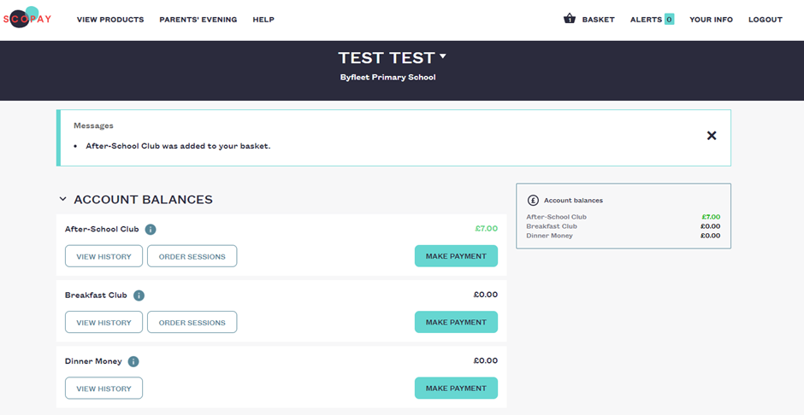
Set 2
To add credit to your balance, you must press ‘Make Payment’. Please note that from January 2020, all non-childcare voucher accounts will need to be in credit before sessions can be booked.
MAKE PAYMENT (1) > Enter Top up Amount (2) > ADD TO BASKET (3) > CHECKOUT (4)
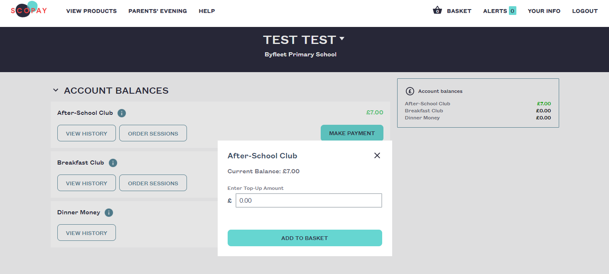
2

3
1

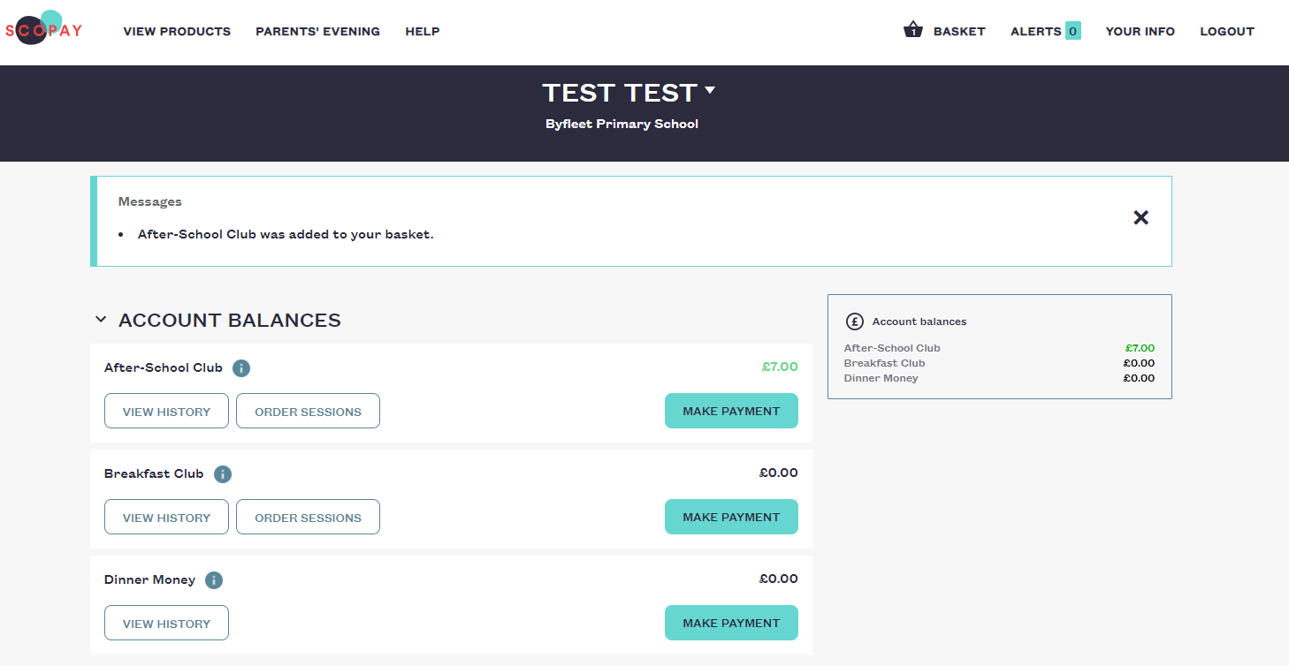

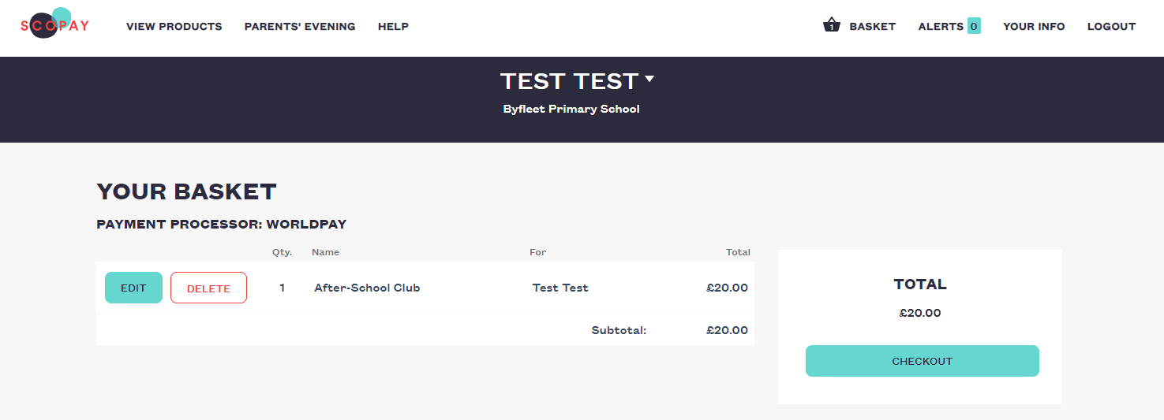
4
Step 3
Click to ORDER SESSIONS (5)
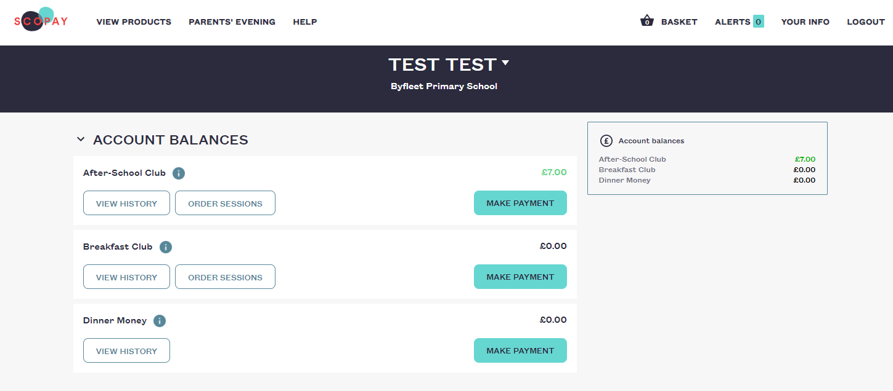
5
A new screen like the one below will appear. When you first log in, it will take you to the current month. (Bookings on this new system are open from November, so you need to click on the right arrow to get the November dates).
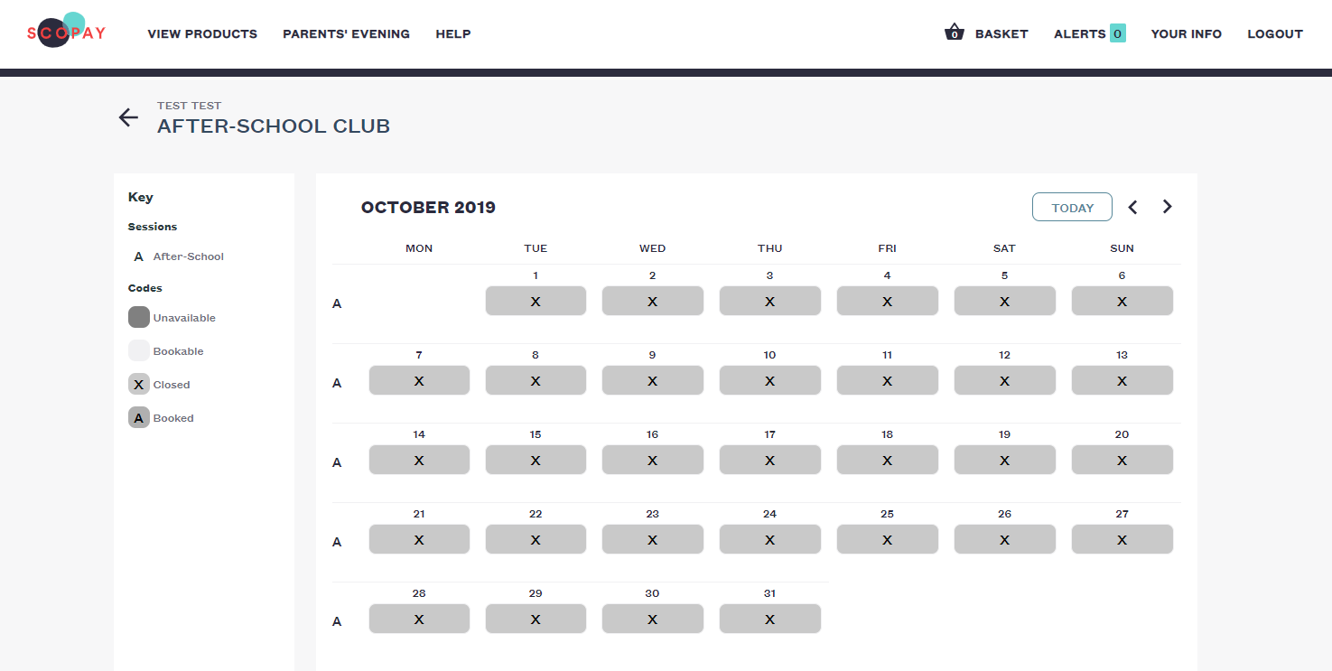
Click on the date you would like to book (6).

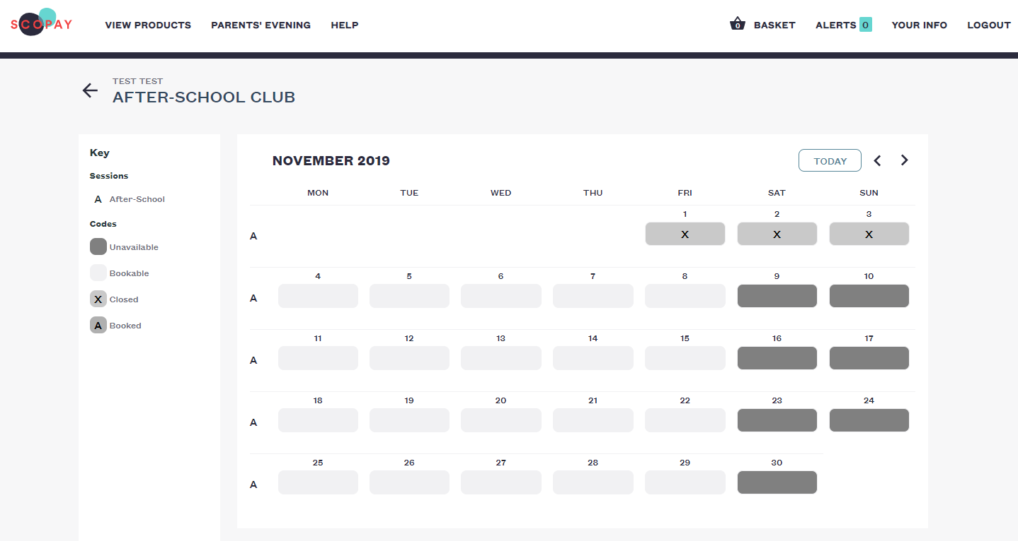
6
Select the session ‘Booked’ Button (A or B) and click OK. This will immediately book your session and charge your account for the cost of the session booked.
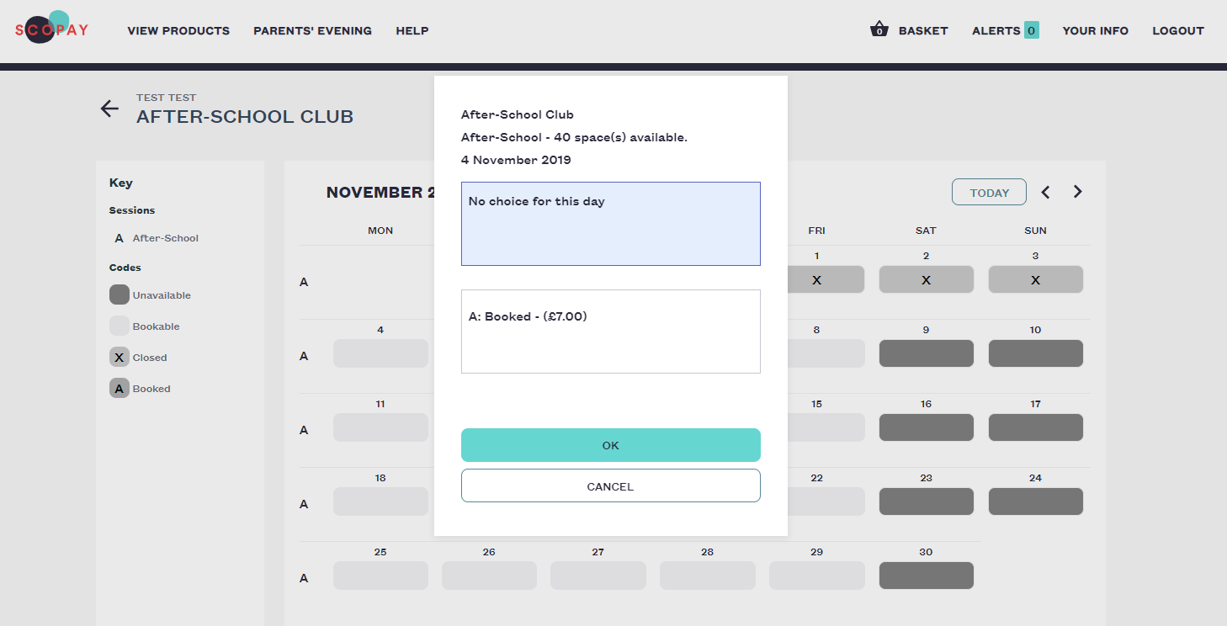
7
Sessions confirmed will show the ‘session code’ i.e. A (8) on the calendar as below.

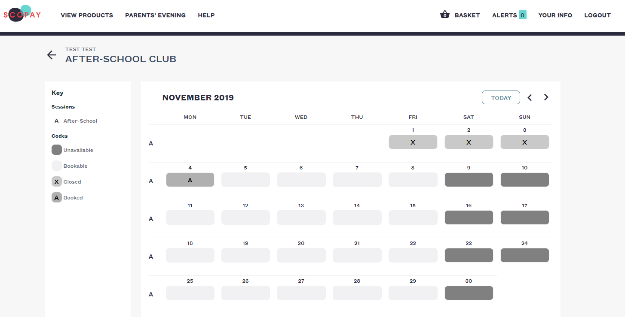
8
Cancelling a Session
If you need to cancel a booking, select the date for the cancellation and the same screen as above will appear. Select ‘No Choice for this day’ and this will cancel your booking and credit the cost back into your account.
Transferring Balances between Breakfast and After-School Clubs
Please pop into the office, should you wish to transfer credit between the clubs. Unfortunately, Scopay doesn’t allow you to make such transfers online.

