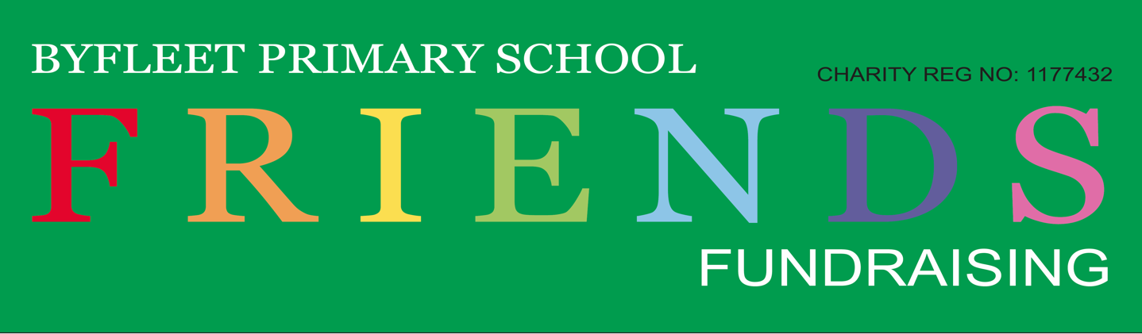
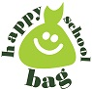
Dear Parent and Guardian,
We are delighted to announce that the school is holding a clothing collection with Happy School Bag Fundraising Project.
This scheme is designed to help schools raise needed funds, as well as helping the environment by keeping textiles away from landfills. By taking part in this scheme you will also help to reduce the amount of reusable textiles from going to landfill and give the clothing a new lease of life.
To take part you simply need to fill any plastic bags with unwanted but clean and reusable clothing, paired shoes and fashion accessories.

We accept:
- Adults and children’s clothing
- Paired Shoes
- Fashion accessories
- Handbags, Belts, Hats
- Jewellery, Perfumes

We don’t accept:

- Uniforms
- Toys, Books, DVD’s
- Duvets, Pillows, Household linen
- Carpets, Blankets, Curtains
- Bric-a-Brack
- Dirty, Damaged, Wet Clothing, unsuitable for reuse.
Remember, the more you fill up the bag the more funds the school can raise. The Happy School Bag van will be collecting from our school on Tuesday 3 March (pick up between 1-2pm). Please bring all your bags to the shelter in the car park and help us have an amazing collection.
Many thanks
The Friends of Byfleet Primary School

